The Big Crunch

The Big Bang Theory is the leading explanation about the origins of the observable universe, and how it formed into the universe as we know it (Howell, 2017). In layman’s terms it states that the universe started with a small dot – no bigger than the one at the end of this sentence – and then expanded over the next 13.8 billion years and formed the universe we are currently living in (Howell, 2017). While astronomers and physicists generally accept this explanation as the origin of the universe, there is a lot of disagreement about the ultimate fate of the universe. Several ideas such as Big Freeze, Big Crunch, Big Bounce, etc., have been proposed by researchers. In this journal, I’m going to discuss the Big Crunch; what I think is the most plausible hypothesis for the termination of the universe – some assumptions required.

First of all, the Big Crunch is a hypothetical scenario where the universe stops expanding and starts to shrink and eventually collapses into itself, engulfing everything in it until it turns into a black hole (Villanueva, 2015). Everything is squeezed into the black hole and becomes a singularity (Villanueva, 2015). However, evidence suggests that this theory is not plausible, because the "universe is actually increasing its rate of expansion at regions [furthest] from us" (Villanueva, 2015). In the world of astronomy, there is little room for the possibility of the universe collapsing into a singularity (Villanueva, 2015). Regardless, this hypothetical scenario should not be disregarded. The universe is a black box, and we don’t know much about it. Our understanding of the universe is constantly changing. Widely accepted theories become obsolete and outlandish hypotheses become facts. A good example of this is the replacement of the geocentric model with the heliocentric model.

Next, let’s assume that the universe is an outrageously powerful super computer. It stores everything such as planets, stars, satellites, atoms, etc., and their respective state. It even calculates all permutations made on these objects. The amount of processing power and memory the universe is capable of is unfathomably high. However, it is still limited to the laws of physics where processing power and memory are both finite. With the exception of the Turing machine, a theoretical model of a machine, no computer in the history of humanity has had infinite memory or processing power (Mullins, 2012). Since the universe’s memory is finite, it is bound to run out. This holds true for the universe that is powering our reality. This begs the question, how will the universe run out of memory? And once it does run out of memory, what will happen?

The second question is easy to answer. It’s the Big Crunch. Once the universe runs out of memory, it’ll start to shrink and eventually collapse into a singularity. The real question is, how will the universe run out of memory. The answer lies in modular arithmetic. Modular arithmetic is a system of numbers that loop back to the end values when the computation yields a value outside of the range of numbers (Lynn, n.d.). In computer science, this is referred to as an overflow1. A good example of this is a clock (Neale, 2011). The diagram below explains how modular arithmetic applies to a clock.

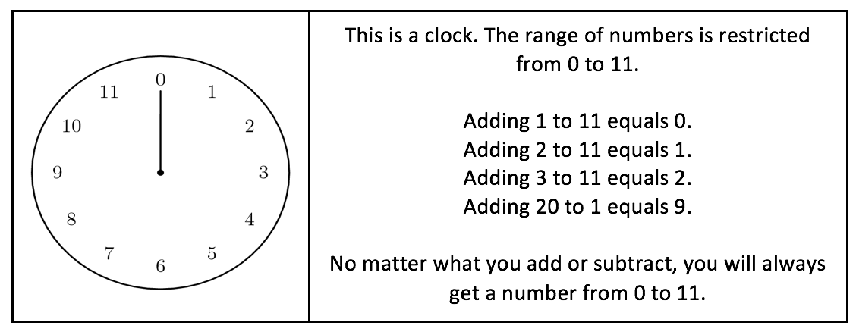

Modular arithmetic is found in programming languages such as Java. In Java, the primitive data type Byte can only hold values ranging from -128 to +127 (Horowitz, 2007). If you try to add 1 to 127, the computer will output -128. This is modular arithmetic (see diagram above).

There are two ways we can think about The Big Bang. The first way is as a timer. Upon expansion, the Big Bang set off a timer. Side note: The Big Bang can be seen as time 0. This timer is increasing all the time, regardless of anything. However, this timer cannot go on forever, because memory is limited. Once memory runs out, the number on the timer wraps around and continues to "increase" until it reaches 0; the singularity. At first, the shrinking will be very slow because everything is far away from each other, but once celestial entities get closer and closer, the contraction will increase due to the strong gravitational pull. Eventually, the universe will collapse in on itself and form a singularity. Billions of years later, it will expand (once again) and form another universe. Through random variation and statistical anomaly, life will find a way and evolve into intelligent creatures. Those intelligent creatures will ponder upon the same questions we do today. It’s a never-ending cycle! (This is known as The Big Bounce).

Another way to analyze the Big Bang is as an event. Since it is the first and foremost event that took place in the universe, it is event 0. Each subsequent event is the successor of the event that took place before it. For example, the event after the Big Bang is the successor of 0, which is 1. The next event is the successor of 1, which is 2. This continues until we reach the universe as we know it today. Currently, we are at a subjectively large number, and it continues to increase at a constant rate. Regardless, this number does not continue to increase forever because the universe’s memory is finite. And because the universe is constantly expanding and events are always occurring, memory is bound to run out. The expansion of the universe is not one big event, rather many events. Once memory “runs out”, the universe will start shrinking. The event number will reach a very large negative number, due to wrapping around, and “increase” until it reaches 0, the singularity. Events from ‘0 to n’, where n is an arbitrarily large number, revolve around expansion of the universe, and events from ‘–n to 0’, revolve around the contraction of the universe. You can also view this as the folding and unfolding of the universe. When the events are increasing on the positive domain, the universe is unfolding, and when the event number hits the negative domain, the universe is folding until it reaches 0; the singularity. As previously stated, the singularity expands and forms another universe. This process is known as The Big Bounce and continues indefinitely.

1 Overflow: https://en.wikipedia.org/wiki/Integer_overflow

These link(s) are here to assist the reader/TA

References

Horowitz, M. (2007, October 26). Why Java can't do addition correctly. Retrieved October 16,

2019, from https://www.cnet.com/news/why-java-cant-do-addition-correctly/.

Howell, E. (2017, November 7). What Is The Big Bang Theory? Retrieved October 16, 2019,

from https://www.space.com/25126-big-bang-theory.html.

Lynn, B. (n.d.). Modular Arithmetic. Retrieved October 16, 2019, from

https://crypto.stanford.edu/pbc/notes/numbertheory/arith.html.

Mullins, R. (2012). What is a Turing machine? Retrieved October 16, 2019, from

https://www.cl.cam.ac.uk/projects/raspberrypi/tutorials/turing-machine/one.html.

Neale, V. (2011, February). An Introduction to Modular Arithmetic. Retrieved October 16, 2019,

from https://nrich.maths.org/4350.

Villanueva, J. C. (2015, December 25). Big Crunch. Retrieved October 16, 2019, from

https://www.universetoday.com/37018/big-crunch/.